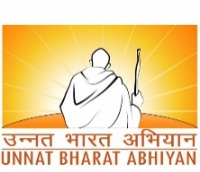
NEW PROPOSAL – TECHNOLOGY DEVELOPMENT

Project Team Members:
Dr.K.Kalimuthu, Dr.C.T.Manimegalai,Dr.SabithaGauni & Mr. Pushpal Das

Project Title: e-Seva for Mandir

Subject: Smart technologies for villages

Village Name: Chettipunniyam

District and State of the Village: Chengalpattu and Tamilnadu

Proposed by (Principal implementing organization/ Department):
ECE Department, SRMIST-KTR Campus

Name and contact of Principal Investigator (PI):
Dr. K. Kalimuthu - 9841631531-kalimutk@srmist.edu.in
DOB: 24.07.1977, Associate Professor, ECE, SRMIST
Name and contact of Co-Principal Investigator (Co-PI):
Dr.C.T.Manimegalai 8870724854 – manimegc@srmist.edu.in
DOB: 24.04.1975, Associate Professor, ECE, SRMIST

Dr.SabithaGauni -8939934554-sabithag@srmist.edu.in
DOB: 23.01.1979, Associate Professor, ECE, SRMIST

Mr. Pushpal Das – 8910497557- pd7000@srmist.edu.in
DOB:18.02.2001, Student, B.Tech, ECE, SRMIST

Collaborating Organization (if any):
SRM IST-KTR Campus, Chengelpet

Mobile and Email of the Contact Person of collaborating Organization(if any):
Dr.V.Thirumurugan
assocdirector.cl@srmist.edu.in M:9940036026

Objective of the Project:
To provide a e-solution, paperless and contactless for the various activities at the Mandir( Temple).

Justification for the project:

i)Problem Statement:

In wake of the COVID-19 pandemic, a simplest QR based e-seva for mandir has been proposed. As suggested by the medical community, contact-free utilizing the public things can prevent spread of COVID-19. To counter this, a novel method is proposed for community.
ii) Priority needs:
To make the religious places, a safe place from being marked as the red zone for the pandemic spread.During a global pandemic, the best and most important ways to prevent the spread of a virus are to wash your hands frequently with soap and water and avoid touching objects placed in public places.

iii ) Proposed Approach /technical intervention/customization:
Based on these factors, we propose contactless services in mandir. All the services like donation, special entrance tickets and other various kinds of pooja seva tickets etc., are provided digitally through simplest QR based e-seva services.

Brief Plan of Activities and Implementation timeline:

QR based e-seva for mandir System:
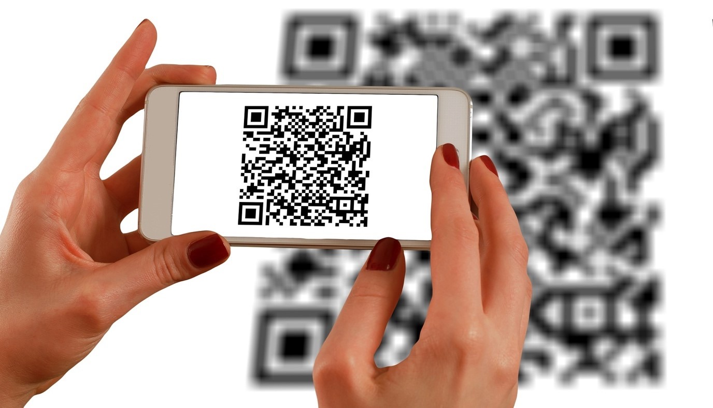
Implementing contactless QR based e-seva for mandir- provides solution for various applications such as donations, special darshan ticket, various kind of pooja tickets. As per this proposed method, mandir administrative office have their own website, it will provide above said seva with payment option using gateway (UPI/netbanking). The main feature of this proposed method is that all these web based services are provided to the users(devotees) through a single QR code.

The devotee(yatree) needs to scan the QR code (LCD display mounted in the wall) using his/her handheld device (Mobile Phone), once he/she scans the code, the mandir website opens up (Mobile view) in the scanned handheld device, showing the above mentioned services with payment details as option to choose in English, Hindi and regional language.
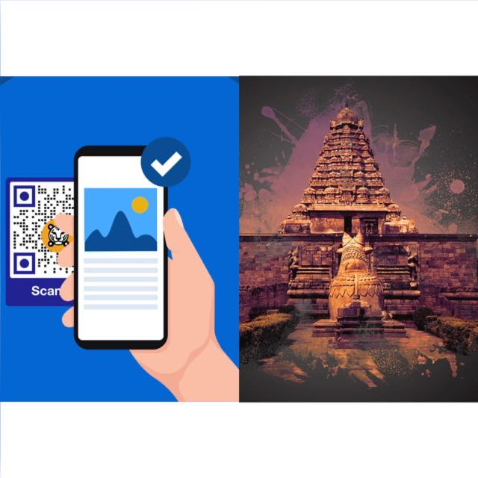
Once the devotee selects the required option, the mode of payment will be prompted and then the payment request will initiated/requested through the selected payment gateway (e-dhaan service he/she need to enter the amount to be offer). Once he/she approves the payment request, the payment is successful. The receipt/ticket will be generated and same will be send to his/her mobile and screened the LCD display mounted on the wall. He/she may shows this digital ticket at the check point. The devotee will do all the above mentioned steps while moving in the queue without any delay. If the payment fails, then they can get in touch with the administrative helpdesk using the contact details provided in the webpage.

Role of primary Stake holders ( Institute):

SRM Institute of Science and Technology will support us with the Lab to Implement and Test our Project.

Methodology, materials and financial resources:

Respiratory viruses like corona virus disease (COVID-19) spread when mucus or droplets containing the virus get into our body through eyes, nose or throat. Most often, this happens through touching things by our hands. Hands are also one of the most common ways that the virus spreads from one person to the next.
- The mandir website is displayed in the wall as in the form of QR code, so no one need to type the URL
- Mobile phone used to scan the QR code and access all the e-seva
- After payment, devotee will get digital ticket in the mobile as well as in the LCD display for his confirmation
Materials:

S.no | Equipment Name | Unit Price in Rs | Quantity | Amount in Rs
1 | PC for Administrative office in the mandir | 55000 | 1 | 55000
2 | LCD Display | 5000 | 1 | 5000
3 | Customised Software Package | 25,000 | 1 | 25,000
4 | Cable and installation | 5000 | 1 | 5000
 | Total |  |  | 90,000

Cost of the facility: Rs 90,000/-

Outcomes/Impact of project :
Product: Simplest QR based e seva for mandir.

Funding from any other sources: NIL

Any other salient aspect(s) of the proposed project :

India, there is an average one shared tap for every five households. We have suffered 13 droughts in the last two decades. COVID-19 is now spreading rapidly, people in villages are facing great inconvenience. They can wash their hands or they can maintain their social distance, avoiding touching the common belongings, but it’s hard to practice all methods of warding off the disease at the same time. Through this project people can stay safe by,
- Avoiding touch with the common belongings and time saving( to avoid standing long queues)
- To make the religious places -Covid free community
- Paperless (save tree) – Fully Digital platform- A step forward towards Digital India

